Ideation Phase
Define the Problem Statements

Date | 03 December 2025
Project Name | Bookstore
Maximum Marks | 2 Marks

Customer Problem Statement – Bookstore Project:
To identify the core problems faced by online book shoppers and independent sellers while browsing, purchasing, and selling books online, and use these insights to guide the design and development of the Bookstore application.
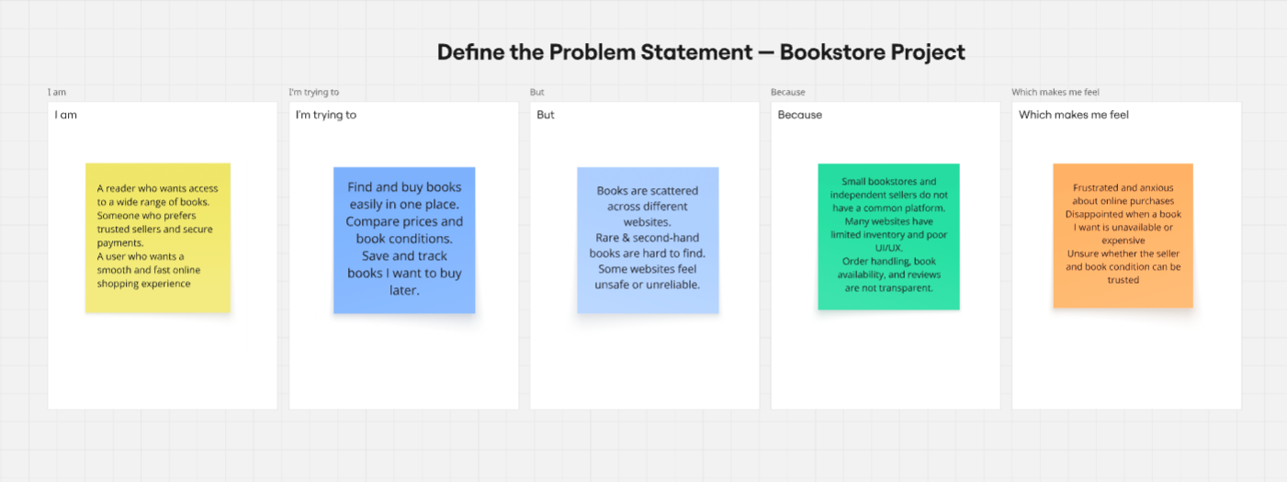

Problem Statement (PS) | I am (Customer) | I’m trying to | But | Because | Which makes me feel
PS-1 | A regular book reader. | find and buy books easily from a single trusted place | books are scattered across multiple websites and stores | there is no centralized platform that lists books from different sellers | frustrated and tired of searching everywhere.
PS-2 |  | compare prices and book conditions before purchasing. | many websites do not provide enough details or transparency | sellers don’t clearly mention condition, reviews, or delivery reliability | unsure and anxious about placing an order.
  A price-
  Conscious
  reader
PS-3 |  | save books for later and track orders smoothly | some websites don’t have wishlist or proper order tracking | features are limited and not user-friendly | disappointed and less motivated to shop.
  A busy reader
PS-4 | An independent bookstore / book seller | sell my books online to reach more buyers | building and managing my own website is expensive and difficult | I don’t have the needed technical skills and resources | helpless and limited in my business growth
PS-5 | A platform administrator | ensure only genuine sellers and quality listings | manual monitoring is time-consuming | there is no automated seller approval or book review validation flow | overwhelmed and worried about platform quality

Readers struggle to discover and purchase books conveniently because inventory is scattered across multiple platforms and small bookstores lack visibility. This causes frustration, low trust, and an unsatisfactory online shopping experience.

